A000-PAC-POLY-Hawai’i-Kaia’i-Menehune-Pregnant Female-Kou wood-1200 CE

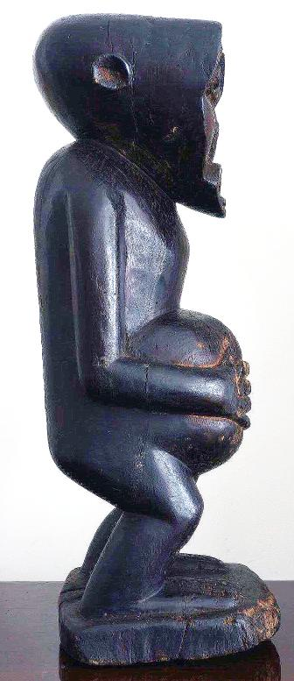 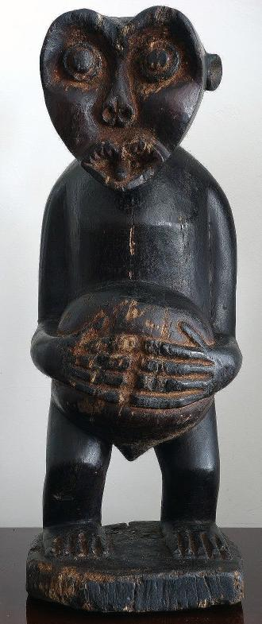 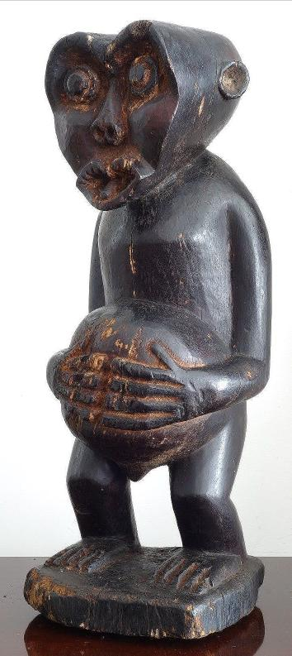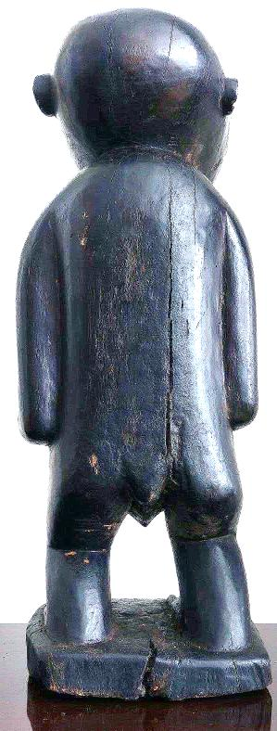

Figs. 1-4. PAC-POLY-Hawai’i-Kaia’i-Menehune-Pregnant Female-Kou wood-1200 CE

Case No.: 13

**Accession No.**

**Formal Label:**

**Display Description:**

This wooden sculpture is carved of indigenous kou wood that is indigenous to Kaua’i. It displays a heart-shaped face that is also found on petroglyphs of these so-called “little” people, who were invoked by the putative first Tahitian settlers of Kaua’i, as commoner inhabitants of the island. When the Tahitians, who had settled the Tahiti archipelago ca. 200 BCE, after a long migration from South East Asia via the Fijian, Samoan and Tongan Archipelagos (Kirch 2002: 230-231), migrated to Hawai’i the ruling *ali’i* or hereditary nobles oppressed the "commoners," or *manahune* (in the Tahitian language) who fled to the mountains to escape servitude. With the arrival of later Hawai’ian immigrants “*manahune”*, became “*menehune”* in the Hawai’ian language. The sense of “little” people, therefore, is not a physical description of the *menehune* but a metaphoric one, identifying them as “little” in the sense of being lower in social status and not of the elevated élite hereditary *ali’i* nobles. Proponents of this theory point to an 1820 census of Kaua’i by Kaumuali’i, the ruling Ali’i Aimoku of the island, which listed 65 people as *menehune* (Joesting 1987, pp. 20-22). Although folklorist Katherine Luomala (1951) believes that the legends of the *menehune* and similar diminutuve creatures are a post-European contact mythology, this sculpture definitively places the origin of the *menehune* in the pre-contact era. It is completely polished and painted with a natural black pigment, further emphasizing the commoner status of the individual who is different from the fairer skinned *ali’i*, who do not get sun-tanned from gardening in the taro fields.

**LC Classification:**

**Date or Time Horizon:**

**Geographical Area:**

**Map:**

**GPS coordinates:**

**Cultural Affiliation: Kaua’I** pre-contact, ca. 1200 AD/CE, pregnant female Hawai’ian Menehune figure, extremely rare.

**Media: Kou wood**

**Dimensions: H** 23-inch,

**Weight:**

**Condition:**

**Provenance:**

Provenance: From the Godeffroy Collection, Umlauf Trading, Leipzig via Frankfurt, Germany. Guaranteed authentic and as described.

**Discussion:**

The Menehune were said to be superb craftspeople. Legends say that the Menehune built temples ([*heiau*](https://en.wikipedia.org/wiki/Heiau)), [fishponds](https://en.wikipedia.org/wiki/Ancient_Hawaiian_aquaculture), roads, [canoes](https://en.wikipedia.org/wiki/Canoe), and houses. Some of these structures that Hawaiian folklore attributed to the Menehune still exist. They are said to have lived in [Hawaiʻi](https://en.wikipedia.org/wiki/Hawaii) before settlers arrived from [Polynesia](https://en.wikipedia.org/wiki/Polynesia) many centuries ago.

In Beckwith's *Hawaiian Mythology*, there are references to several other forest dwelling races: the [*Nawao*](https://en.wikipedia.org/wiki/Nawao), who were large-sized wild hunters descended from [Lua-nuʻu](https://en.wikipedia.org/w/index.php?title=Lua-nu'u&action=edit&redlink=1), the *mu* people, and the *wa* people.[[1]](https://en.wikipedia.org/wiki/Menehune" \l "cite_note-1)

Some early scholars theorized that there was a first settlement of Hawaiʻi, by settlers from the [Marquesas Islands](https://en.wikipedia.org/wiki/Marquesas_Islands), and a second, from [Tahiti](https://en.wikipedia.org/wiki/Tahiti). The Tahitian settlers oppressed the "commoners", the *manahune* in the [Tahitian language](https://en.wikipedia.org/wiki/Tahitian_language), who fled to the mountains and were called Menahune. Proponents of this theory point to an 1820 census of [Kauaʻi](https://en.wikipedia.org/wiki/Kauai) by [Kaumualiʻi](https://en.wikipedia.org/wiki/Kaumualii), the ruling [*Aliʻi Aimoku*](https://en.wikipedia.org/wiki/Alii) of the island, which listed 65 people as *menehune*.[[2]](https://en.wikipedia.org/wiki/Menehune" \l "cite_note-2)

Folklorist [Katharine Luomala](https://en.wikipedia.org/wiki/Katharine_Luomala) believes that the legends of the *Menehune* are a post-European contact mythology created by adaptation of the term *manahune* (which by the time of the colonizing of the Hawaiian Islands by Europeans had acquired a meaning of "lowly people" or "low social status" and not diminutive in stature) to European legends of [brownies](https://en.wikipedia.org/wiki/Brownie_(elf)).[[3]](https://en.wikipedia.org/wiki/Menehune" \l "cite_note-3) '"It is claimed that "Menehune *are not mentioned in pre-contact mythology, although this is unproven since it was clearly an oral mythology; the legendary "overnight" creation of the Alekoko fishpond, for example, finds its equivalent in the legend[[4]](https://en.wikipedia.org/wiki/Menehune" \l "cite_note-4) about the creation of a corresponding structure on* [*Oʻahu*](https://en.wikipedia.org/wiki/Oahu)*, which was supposedly indeed completed in a single day — not by* menehune *but, as a show of power, by a local* [aliʻi](https://en.wikipedia.org/wiki/Alii) *who demanded every one of his subjects to appear at the construction site and assist in building.*

No physical evidence for the existence of a historical people that fits the description of the Menehune has been discovered.[[5]](https://en.wikipedia.org/wiki/Menehune" \l "cite_note-5)

* However, the following structures have been cited as evidence:
* Menehune fishpond wall at [Niumalu](https://en.wikipedia.org/wiki/Niumalu), Kauaʻi
* [Kīkīaola](https://en.wikipedia.org/wiki/Kikiaola) ditch at [Waimea](https://en.wikipedia.org/wiki/Waimea,_Kauai_County,_Hawaii), Kauaʻi
* [Necker Island](https://en.wikipedia.org/wiki/Necker_Island_(Northwestern_Hawaiian_Islands)) structures
* *Pa o ka menehune*, breakwater at [Kahaluʻu Bay](https://en.wikipedia.org/wiki/Kahaluu_Bay).[[7]](https://en.wikipedia.org/wiki/Menehune" \l "cite_note-7)
* [Ulupo Heiau](https://en.wikipedia.org/wiki/Ulupo_Heiau_State_Historic_Site) at Kailua, Oahu

**References:**

1. Beckwith, Martha. 1970. Hawai’ian Mythology. Honolulu: University of Hawai’i Press.
2. Joesting, Edward. 1984. Kaua’i, The Separate Kingdom. Honolulu, Hawaii: [University of Hawai’i Press](https://en.wikipedia.org/wiki/University_of_Hawaii_Press) and Kaua’i Museum Association.
3. P.V. Kirch. 2002. *On the Road of the Winds – An Archaeological History of the Pacific Islands Before European Contact*. Berkeley, Los Angeles, London: 2002,
4. Luomala, Katharine. 1951. The Menehune of Polynesia and other mythical little people of Oceania. Bernice P. Bishop Museum Bulletin  no. 203. Honolulu: Bernice P. Bishop Museum.

Appendix: Photograph showing the tree rigs of the kou wood of the sculpture’s base.

